Customer Privacy Notice - Easy-to-Read

Organisations like Somerset Care have to keep information about people. It is law that that Somerset Care must keep this information safe and secure.

We must tell you about this and this is why we have produced this Easy-to-Read Privacy Notice.

This notice explains how we use any information we collect about you, how you can tell us if you need to change the way that we use your information and your rights about the information we have about you.

Your rights about your personal information

This privacy policy explains how you can tell us if you prefer to limit the use of that information and procedures that we have in place to look after your privacy.

Information about you that we may keep

Somerset Care will keep information about you to make sure that we can take the very best care of you.



Somerset Care need to keep information such as:
- Your basic details e.g. name, address, date of birth, contact details.
- What kind of help and support you might need.
- Your likes and dislikes.
- Details about your health (which we have to keep extra safe).

Information about your health that we will keep


Somerset Care will use your health information to:

- Help to work out the type of help and support you need to protect your health.
- Keep you safe and healthy.
- Help you find the right treatment.



Somerset Care must follow strict rules when collecting, storing, or sharing information about you.

How we keep your information safe:


Somerset Care will always keep your information private and safe.

The only people that we will let see your information are:

- People with permission like a member of your family who will support and help you to understand your records.
- People from any organisation whose job it is to help you.
- People who have the right to see it by law.

People or organisations who may have a legal reason to see your information.


These include:
- Healthcare professionals such as your GP, consultants at the hospital, community doctors and nurses, social workers, pharmacy staff etc.
- Your local council but only if they need to see it.
- The police or security services.

How long we keep your information for:


- The amount of time we keep your information will be in line with how long the law says we must keep it for, and the rules set by other organisations.
- The amount of time we keep your information will depend on why it was needed in the first place.
- We will follow a Records Retention Policy; this will tell us how long we keep your information.

You have these rights when it comes to your information:

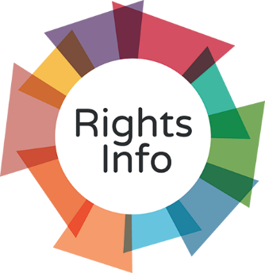

- The information we keep about you is yours.
- We will make sure it is kept private and is only used properly.
- You can ask to see a copy of the information we have about you.
- If you think the information, we have about you is wrong, or has parts missing, you can ask us to correct it.



- If you think we have information about you that is no longer needed, you can ask us to delete it. (But we will not be able to delete it if the law says it is still needed).


- You can ask us to stop some of the ways that we use your information, even if you do not want your information deleted.



- You can ask us to delete your information by withdrawing consent (consent is when you gave us the permission to use your information).

If we cannot do what you have asked us to do, or you need help then you can contact the:

Data Protection Officer
TEL: 01823 448150
EMAIL: Trudy.Craig@somersetcare.co.uk

If you are not happy in any way with how we have handled your information, you are required to raise your concerns with us first so we can resolve them quickly.



If you are unhappy with the response, you have the right to raise this with the Information Commissioner’s Office from Monday to Friday from 9.00am-5.00pm
or call their helpline on 0303 123 1113.
Or Use the live chat function on their website:https://ico.org.uk/global/contact-us/

